1. LOGIN TO YOUR BLUEMIX ACCOUNT

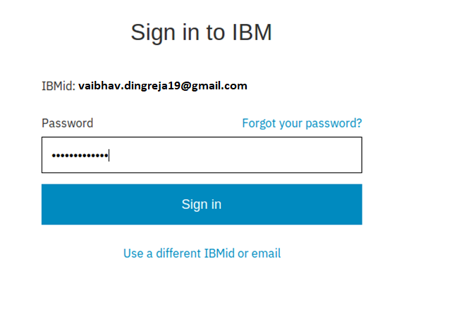

1. SELECT SPACE AS DEV AND SELECT UNITED KINGOM

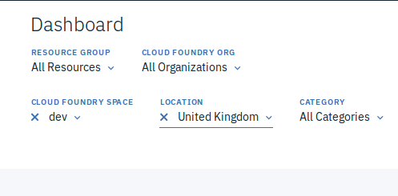

1. TO KNOW THE VERSION



1. SETTING API END POINT

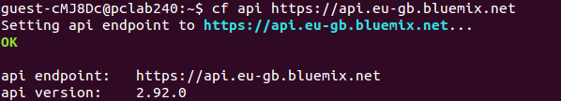

1. LOGIN THROUGH YOUR MAIL ID

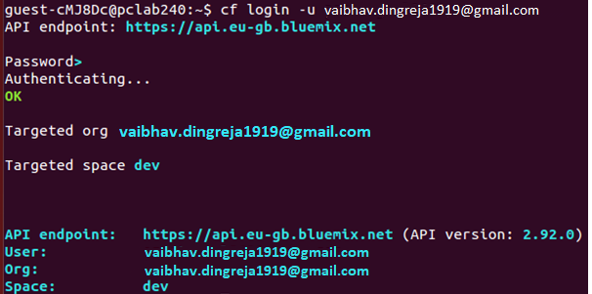

1. DOWNLOAD THE WAR FILE

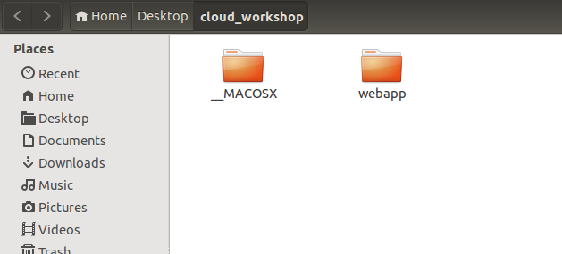

1. CHANGE YOUR DIRECTORY AND THEN SET THE TARGET SPACE AND ORG

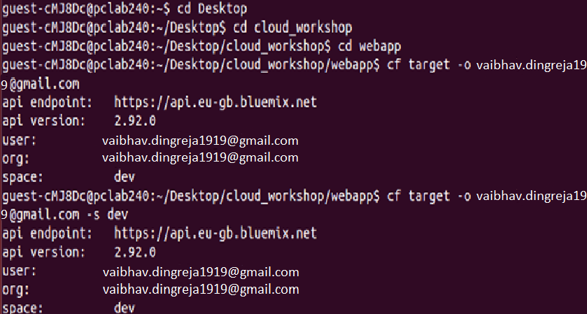

1. NOW PUSH YOUR WEB APPLICATION

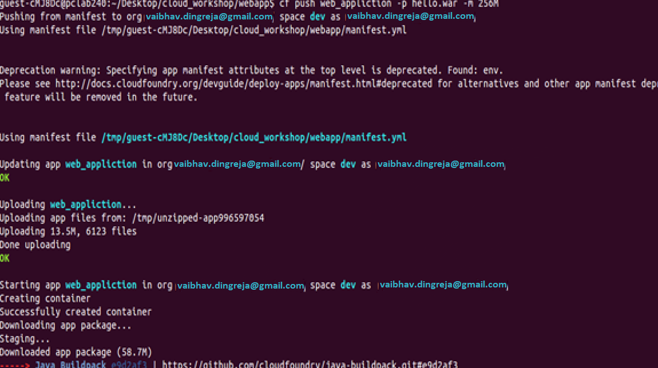

1. YOU CAN NOW SEE YOUR WEB APPLICATION RUNNING ON DASHBOARD

